Spectral coherence: USDJPY and USDCHF
Method 21 / daily log returns / Welch magnitude-squared coherence / Alpari D1 full available history

Study setup
Logical pair: USDJPY , USDCHF
Broker symbols: USDJPY_i , USDCHF_i
Snapshot: 2026-11-03_majors_alpari_D1
Timeframe: D1
Matched return window: 1999-01-05 to 2026-11-02 (UTC bar dates)
Matched return count n: 7185
Dropped unfinished last bar dated 2026-11-03 UTC after a tick-volume check against the prior complete day.
Welch: fs=1.0, nperseg=256, noverlap=128, window=hann, detrend=constant
Headline: gamma^2 nearest f=1/5; also 1/21 and 1/63
Complete matched rows (Excel): USDJPY-USDCHF_Spectral_D1.xlsx
Complete matched rows (HTML table): USDJPY-USDCHF_Spectral_D1_data.html

Method carried forward
Magnitude-squared spectral coherence gamma^2(f) measures shared linear power between matched daily log returns of close, ln(close_t / close_t-1), at each frequency f (cycles per day). Quotes are not inverted. Welch settings are frozen: fs=1, nperseg=256, noverlap=128, window=hann, detrend=constant. Headline is gamma^2 at the frequency bin nearest f=1/5 (five-day cycle from the formula sheet). Also reported: gamma^2 nearest f=1/21 and f=1/63, mean gamma^2 over the frequency grid, and phase of the cross-spectrum at the 1/5 bin. Coherence is unsigned (0 to 1); phase carries timing. Same-sample Pearson r is a side check only. This is not causation and not a trading signal.

Results (headline)
gamma^2 near 1/5: 0.225611
bin f (1/5): 0.199219
phase at 1/5 (rad): 0.104061
gamma^2 near 1/21: 0.141938
gamma^2 near 1/63: 0.124486
mean gamma^2: 0.181330
Pearson r: 0.399461

Target-frequency summary
period | target_f | f_bin | gamma2 | phase_rad
5 | 0.2 | 0.19921875 | 0.22561101 | 0.10406138
21 | 0.04761905 | 0.046875 | 0.1419384 | -0.38219764
63 | 0.01587302 | 0.015625 | 0.12448642 | -0.20532471

Conclusion
Headline gamma^2 near f=1/5 for USDJPY and USDCHF: 0.2256 (bin f=0.199219, phase=0.1041 rad). At ~1/21: 0.1419; at ~1/63: 0.1245. Mean gamma^2 = 0.1813. Pearson r = 0.3995. This is frequency-domain linkage, not a trading signal.

Charts
Daily closes

Daily log returns

Spectral coherence gamma^2(f)
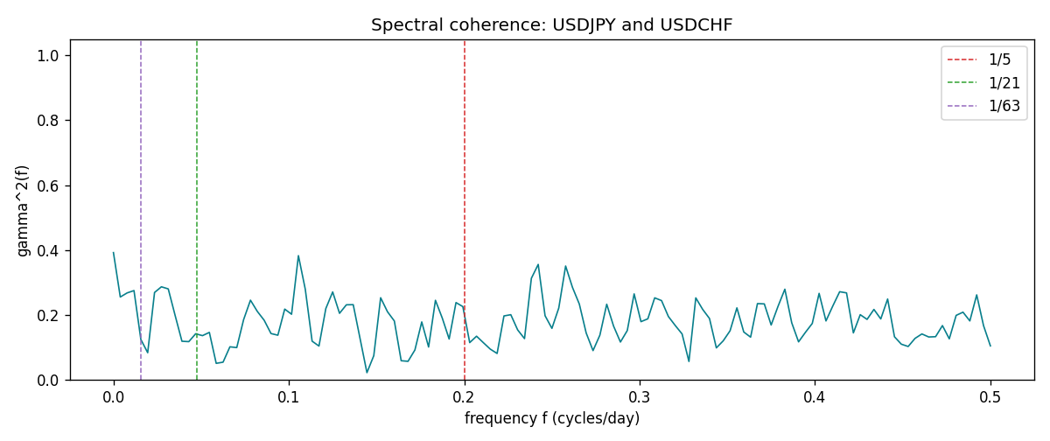

Data report
Matched rows and the coherence sheet are in the sibling Excel workbook named USDJPY-USDCHF_Spectral_D1.xlsx. Embedding all rows as a Word table is impractical; this file holds column summaries and the first and last 15 matched rows.
Columns: time, USDJPY_open, USDCHF_open, USDJPY_high, USDCHF_high, USDJPY_low, USDCHF_low, USDJPY_close, USDCHF_close, USDJPY_tick_volume, USDCHF_tick_volume, USDJPY_spread, USDCHF_spread, USDJPY_real_volume, USDCHF_real_volume, USDJPY_log_return, USDCHF_log_return
Column summaries (matched calculation rows)
column | count | mean | std | min | 25% | 50% | 75% | max
USDJPY_open | 7185 | 113.80726 | 19.2236 | 75.693 | 104.38 | 110.984 | 120.69 | 163.824
USDCHF_open | 7185 | 1.0974395 | 0.25223318 | 0.72022 | 0.92053 | 0.98988 | 1.2375 | 1.8219
USDJPY_high | 7185 | 114.30433 | 19.285132 | 76.001 | 104.865 | 111.442 | 121.257 | 163.978
USDCHF_high | 7185 | 1.1027315 | 0.25397793 | 0.73305 | 0.92474 | 0.99353 | 1.2422 | 1.8313
USDJPY_low | 7185 | 113.28455 | 19.151449 | 75.402 | 103.87 | 110.53 | 120.17 | 163.628
USDCHF_low | 7185 | 1.0923205 | 0.25064913 | 0.08565 | 0.91719 | 0.98622 | 1.2315 | 1.8121
USDJPY_close | 7185 | 113.82023 | 19.238853 | 75.811 | 104.38 | 111.025 | 120.68 | 163.851
USDCHF_close | 7185 | 1.0974333 | 0.25214008 | 0.72025 | 0.92079 | 0.98995 | 1.2376 | 1.8217
USDJPY_tick_volume | 7185 | 106345.59 | 179437.4 | 149 | 9958 | 53202 | 92889 | 1803508
USDCHF_tick_volume | 7185 | 74334.331 | 113494.7 | 18 | 12809 | 40241 | 70443 | 858589
USDJPY_spread | 7185 | 20.263883 | 17.612444 | 0 | 6 | 11 | 30 | 50
USDCHF_spread | 7185 | 26.03215 | 24.694045 | 0 | 5 | 16 | 50 | 100
USDJPY_real_volume | 7185 | 3.4781051e+10 | 1.6093614e+11 | 0 | 0 | 0 | 0 | 3.8834203e+12
USDCHF_real_volume | 7185 | 2.3294091e+10 | 8.9133595e+10 | 0 | 0 | 0 | 0 | 1.9331921e+12
USDJPY_log_return | 7185 | 4.82e-05 | 0.00620617 | -0.03908203 | -0.00320044 | 0.00011473 | 0.00340924 | 0.05184024
USDCHF_log_return | 7185 | -6.962e-05 | 0.0065941 | -0.19545699 | -0.0033516 | 8.06e-05 | 0.00332472 | 0.09051364
First 15 matched rows (selected columns)
time | USDJPY_log_return | USDCHF_log_return
1999-01-05 | -0.00017868311 | 0.0039424743
1999-01-06 | 0.0075660159 | 0.013605652
1999-01-07 | -0.012851583 | -0.0093883841
1999-01-08 | -0.0047719894 | 0.011040268
1999-01-11 | -0.016195423 | 0.0052963193
1999-01-12 | 0.032310364 | -0.0098275602
1999-01-13 | 0.0081373171 | -0.018259701
1999-01-14 | 0 | -0.0024256692
1999-01-15 | 0.0055343401 | 0.01794228
1999-01-18 | 8.7600193e-05 | -0.0031856384
1999-01-19 | -0.0056219403 | -7.2518946e-05
1999-01-20 | -0.0053879917 | 0.0072259871
1999-01-21 | 0.0084664056 | -0.0038232689
1999-01-22 | 0.0060412564 | -0.0001445609
1999-01-25 | -0.0073594164 | 0.0024546976
Last 15 matched rows (selected columns)
time | USDJPY_log_return | USDCHF_log_return
2026-10-13 | -0.0018932826 | -0.0024955621
2026-10-14 | 7.5800166e-05 | 0.0029388325
2026-10-15 | -0.0018524319 | -0.0097855323
2026-10-16 | -0.00037976126 | -0.0036230826
2026-10-19 | 0.0034946841 | 0.0036351779
2026-10-20 | -0.0022546642 | -0.0026281224
2026-10-21 | -0.00032883504 | -0.00040027413
2026-10-22 | -0.0085942669 | -0.0048036381
2026-10-23 | 0.00035080446 | 0.005652514
2026-10-26 | 0.0041238746 | 0.0018407959
2026-10-27 | 0.0027651658 | 0.0026100526
2026-10-28 | -0.00095679538 | -0.0010142111
2026-10-29 | -0.00038043789 | -0.0048680164
2026-10-30 | -0.0010596481 | 0.00071594559
2026-11-02 | 0.0026438521 | -0.0071459744
First 15 frequency bins
f | gamma2 | phase_rad | period_days
0 | 0.39221813 | 0 | inf
0.00390625 | 0.25525533 | -0.23954582 | 256
0.0078125 | 0.26790495 | -0.11749042 | 128
0.01171875 | 0.27506958 | 0.06748353 | 85.333333
0.015625 | 0.12448642 | -0.20532471 | 64
0.01953125 | 0.0835344 | -0.17355813 | 51.2
0.0234375 | 0.26920534 | 0.08440723 | 42.666667
0.02734375 | 0.28674452 | 0.06976302 | 36.571429
0.03125 | 0.28028278 | -0.06143628 | 32
0.03515625 | 0.19871776 | -0.11392898 | 28.444444
0.0390625 | 0.11884544 | -0.04118196 | 25.6
0.04296875 | 0.11764987 | -0.35764333 | 23.272727
0.046875 | 0.1419384 | -0.38219764 | 21.333333
0.05078125 | 0.13616383 | -0.25240845 | 19.692308
0.0546875 | 0.14620316 | -0.34898984 | 18.285714

